Ethan Haywood
ST10530024
IMAD5112p/w

This report details the development of "Campsite Commander" a mobile application engineered to store camping gear and food supplies
Figure 1 App icon
Functionally, the UX prioritizes seamless interactions, incorporating robust error handling, logical input/output flows, and responsive button feedback. Built exclusively for the Android ecosystem, the app was coded using Kotlin within the Android Studio environment.
Throughout the development lifecycle, GitHub served as the backbone for version control. It was utilized to monitor codebase alterations, securely store UI layout files, enable rollbacks to previous states, and maintain a transparent developmental timeline via structured commit logs. Ultimately, the report concludes that "Campsite Commander" successfully illustrates how intuitive design paired with proper technical tools can help manage the packing list, while also highlighting GitHub's critical role in organized project management and version tracking.

GitHub link below:
https://github.com/IIEVCPMB/exam-practicum-imad5112-gr02-jackhaywood983-rgb.git

Reference
Google Gemini. (2026) Used to get some ideas for the app. Chat log Available at: https://www.google.com/search?q=ideas+for+a+app+for+inventory+app+for+outdoor&client=ms-android-vf-za-rvc3&hs=iTi&sca_esv=4a455b0f3ad2390b&sxsrf=ANbL-n7qOek1tAoRHfKlvN_CLJkpDOsndg%3A1781073923243&udm=50&fbs=ADc_l-aN0CWEZBOHjofHoaMMDiKpV6Bbbmx4QVaoKkiRQ2jlwvMg54BMciw6zYi-UcSdrQCntYgVKnodjp8mHRtWfsydyTHVgJqo81Db0eSEgsrx4hZRN-mIKEH73yDO3F1btv-RadtarUbyIisklJqSMYzhHvCnHu14LzlPVeVC8_MfQWYj5EGLPgcKqV355LiGSivvxuAjcHNdrc9JvghpTHJZaDnjoQ&aep=1&ntc=1&sa=X&ved=2ahUKEwitxI20ifyUAxXBXUEAHRXyDKQQ2J8OegQIERAE&mstk=AUtExfDR0D85wQG_eMYwuS1uaL-TUu-i_x4TnvJre1Nfl8CWV36MMZzto-B_MaZM8u5zyStu2vgmlK0t_S4tY9T6Rb1qeRClN-dr7iJSa5cnq1navCtYSzXAHNUzYlZn-yzUK0xizIr6YDmg6HqcaDv4IN4MfctNsYEZ_as-LTIM9VmCeFD0-Hx2QGhTXIwjxa6qUJ5YgT06DIX9EH9kwtzibY0yk1vBsXf_EYFoCMN5QJHEbrGwdI4AaVoJ8UNUjM1M5uWyVABjllqLHg35uuENhJVdFujuTEkNyB_iGOzWKeanZbKli9hNPdJSR1M9Wg0M4HAxMqz9DgXmgXvSW1fW6sGm9lVeOJsmoA&csuir=1&mtid=Wxopar3vCqqMhbIP2fO5kQ4 (Accessed: 10 June 2026).
Code reference: Ngema,F. (2026) Introduction to Mobile Application Development. Emeris

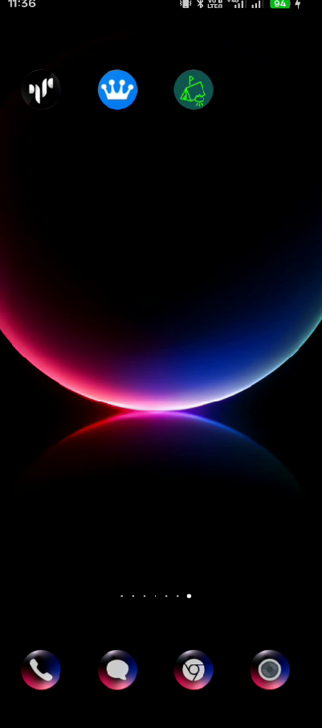
Figure 2 shows app icon works

